explain me clearly about 2-tier and 3-tier architecture in simple and understandable way and also help me how you build the infrastructure in AWS. above is my interview question in devops
Below is a clear, interview-friendly explanation of 2-tier and 3-tier architecture, followed by how you would build each one on AWS from a DevOps perspective. I’ll keep it simple, practical, and easy to remember.

1️⃣ What is Tier Architecture? (Simple idea)
A tier means a layer of responsibility in an application.
Each tier has one main job, for example:
- Showing the UI
- Running business logic
- Storing data
Separating these makes applications scalable, secure, and maintainable.

2️⃣ 2-Tier Architecture (Client ↔ Server)
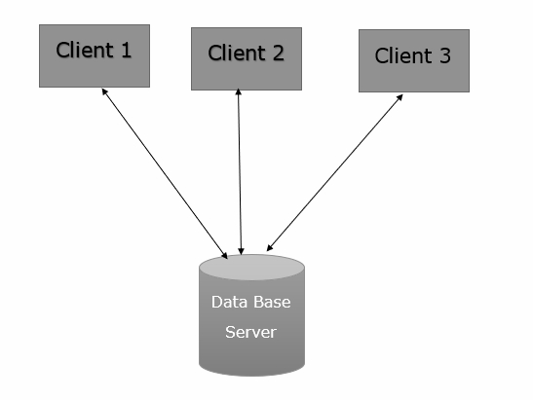
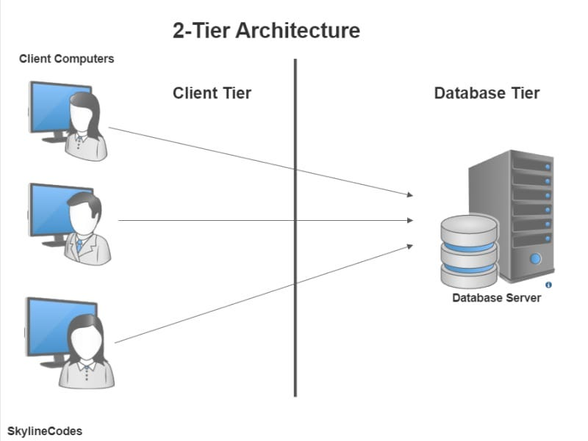
📌 What it is
In 2-tier architecture, the application has two layers:
- Client Tier
  - UI (browser, desktop app)
  - Sometimes includes business logic
- Database Tier
  - Database server (MySQL, PostgreSQL, etc.)
📌 Client talks directly to the database

🧠 Simple Example
- A desktop app connects directly to a database
- A small internal web app where frontend connects straight to DB

✅ Advantages
- Simple to build
- Less infrastructure
- Good for small applications
❌ Disadvantages
- Poor scalability
- Weak security (DB exposed)
- Hard to maintain for large apps

☁️ 2-Tier Architecture on AWS
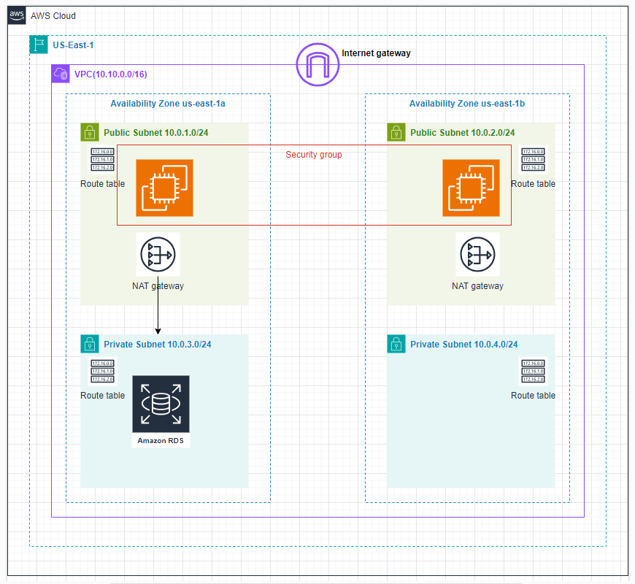
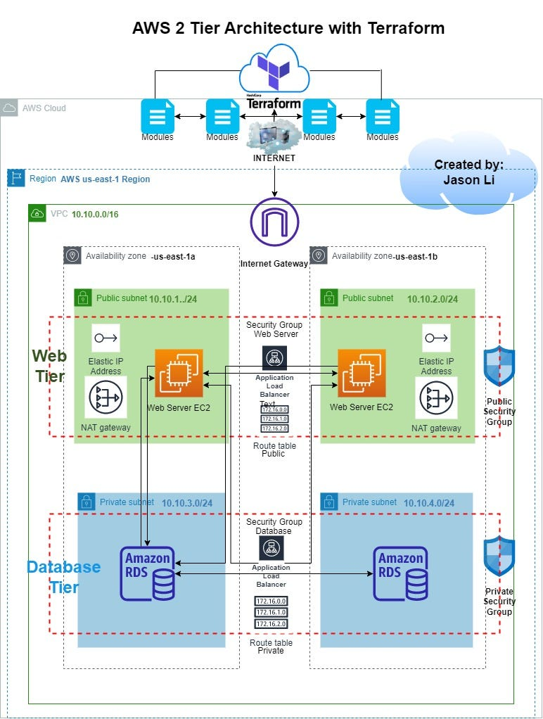
How you build it:
- EC2 Instance
  - Runs frontend + backend together
- RDS
  - MySQL / PostgreSQL database
- Security Group
  - EC2 allowed to access RDS
📌 Traffic flow
User → EC2 (UI + Logic) → RDS
📌 Interview Tip
“2-tier is suitable only for small or legacy systems. In real production, we usually prefer 3-tier.”

3️⃣ 3-Tier Architecture (Most Common in Production)
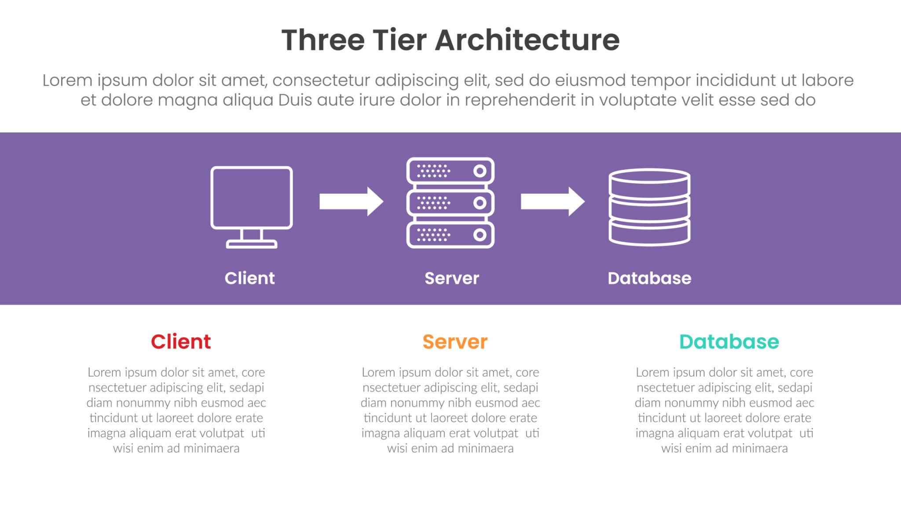
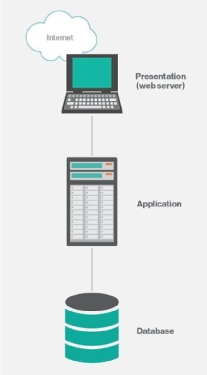
📌 What it is
In 3-tier architecture, responsibilities are clearly separated:
- Presentation Tier
  - UI (Frontend)
- Application Tier
  - Business logic / APIs
- Database Tier
  - Data storage
📌 Each tier communicates only with the next tier

🧠 Simple Example
- Frontend: React / Angular
- Backend: Java / Node.js / Python API
- Database: MySQL / PostgreSQL

✅ Advantages
- High scalability
- Better security
- Easy maintenance
- Industry standard
❌ Disadvantages
- More infrastructure
- Slightly complex setup

☁️ 3-Tier Architecture on AWS (DevOps View)
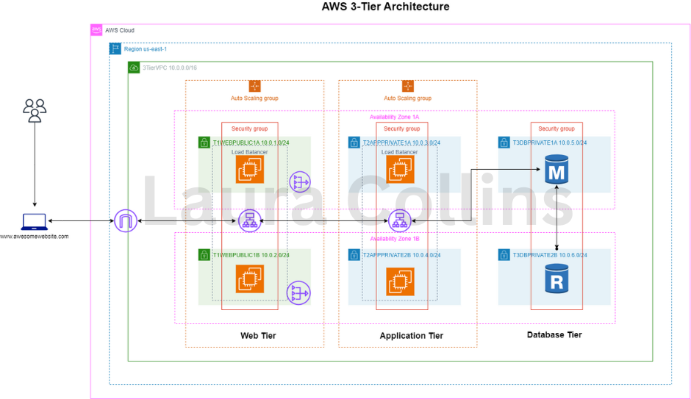
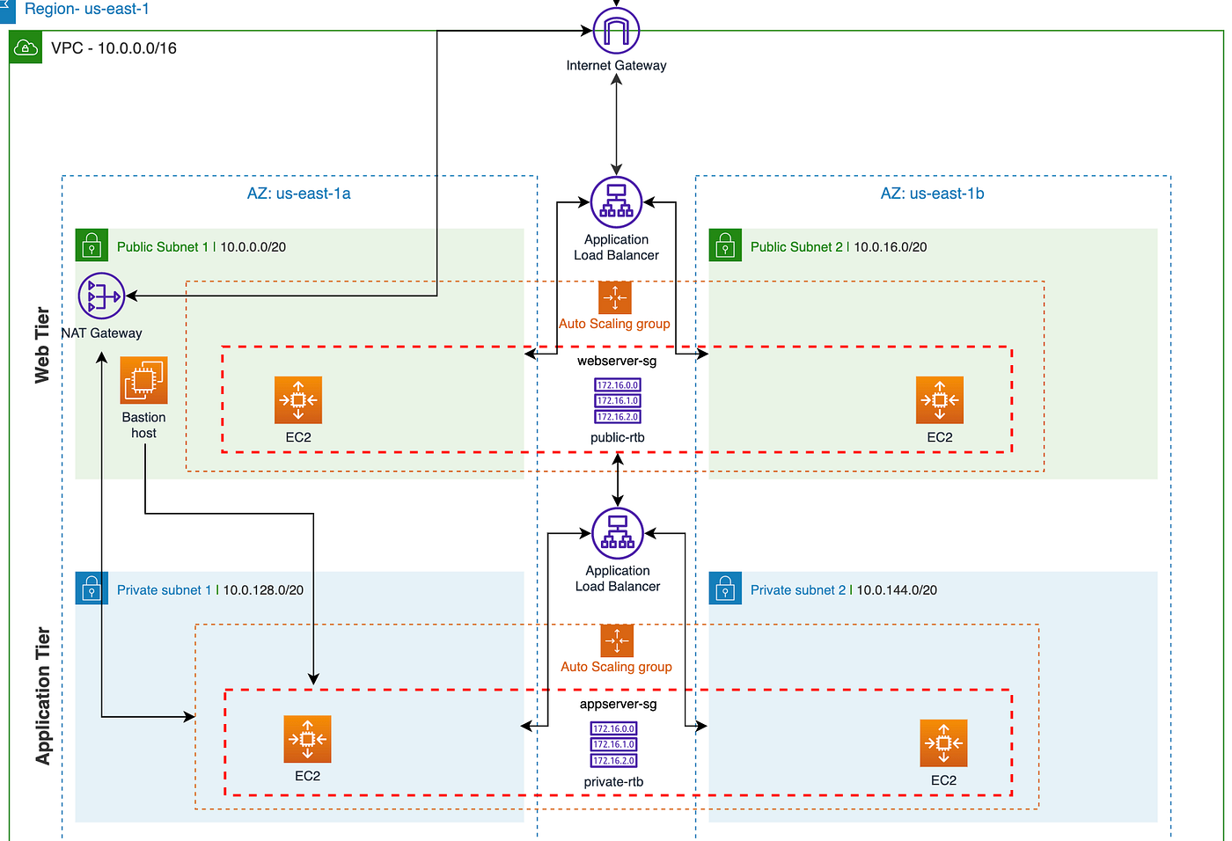
🔧 Components Used in AWS
- Presentation Tier
  - ALB (Application Load Balancer)
  - Frontend EC2 / ECS
  - Public Subnet
- Application Tier
  - Backend EC2 / ECS
  - Auto Scaling Group
  - Private Subnet
- Database Tier
  - RDS (MySQL/Postgres)
  - Private Subnet

📌 Step-by-Step Infrastructure Setup
🔹 Step 1: Network
- Create VPC
- Public Subnet (ALB)
- Private Subnets (App & DB)
- Internet Gateway + NAT Gateway
🔹 Step 2: Presentation Tier
- ALB in Public Subnet
- Frontend instances behind ALB
🔹 Step 3: Application Tier
- Backend EC2 instances
- Auto Scaling Group
- Only accessible from ALB
🔹 Step 4: Database Tier
- RDS in private subnet
- Accessible only from backend SG

🔐 Security Groups (Very Important for Interview)
Component | Allowed Access
ALB | Internet (80/443)
App EC2 | Only from ALB
RDS | Only from App EC2

📌 Traffic Flow
User → ALB → Frontend → Backend → RDS

🔁 CI/CD + DevOps Touch (Interview Bonus)
As a DevOps engineer, you can say:
- CI/CD using GitHub Actions / Jenkins
- Docker for app packaging
- Terraform for infra
- Monitoring using CloudWatch
- Logs using ELK / CloudWatch Logs

🔥 Interview One-Line Comparison
Feature | 2-Tier | 3-Tier
Layers | Client + DB | UI + App + DB
Scalability | Low | High
Security | Weak | Strong
Production Use | Rare | Very Common

🎯 Final Interview Answer Summary
“2-tier architecture is simple where client directly talks to the database. It’s good for small systems.
3-tier architecture separates presentation, application, and database layers, which improves scalability, security, and maintainability. In AWS, we use ALB, EC2/ECS, Auto Scaling, and RDS to implement a secure 3-tier architecture.”

